**Task on CloudFront.**

**#######################**

1. **Configure VPC peering in cross regions.**

* To VPC peering we need to create one server in another region ,different account
* Now create on ec2 instance in another region(eg:ohio)
* Using default vpc and create new pem key

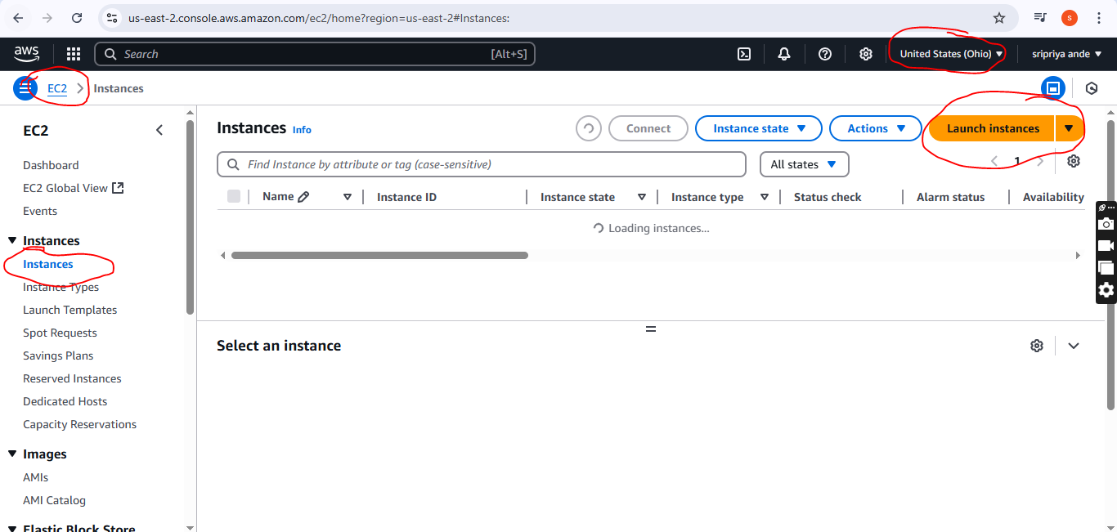

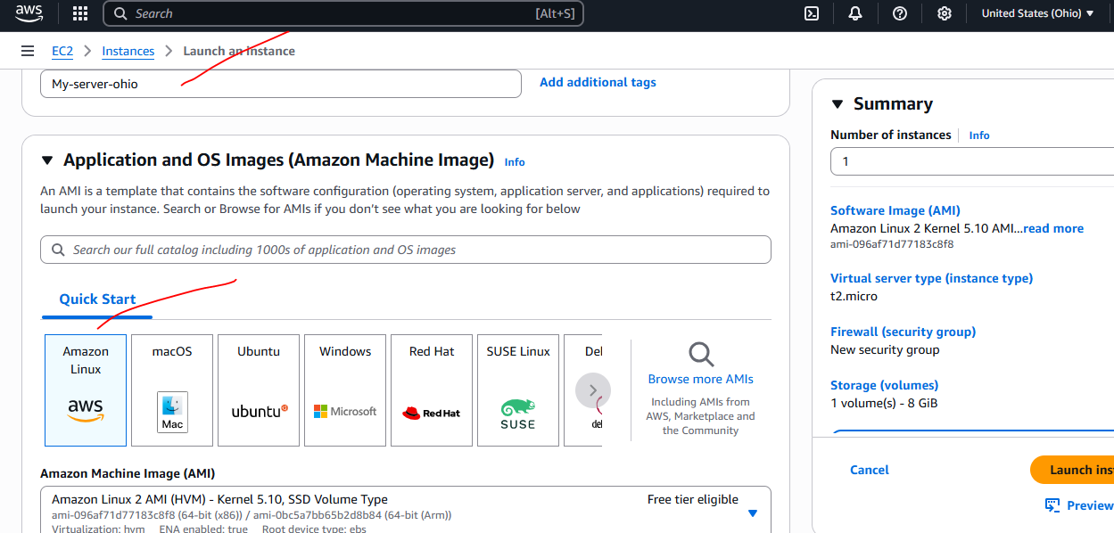

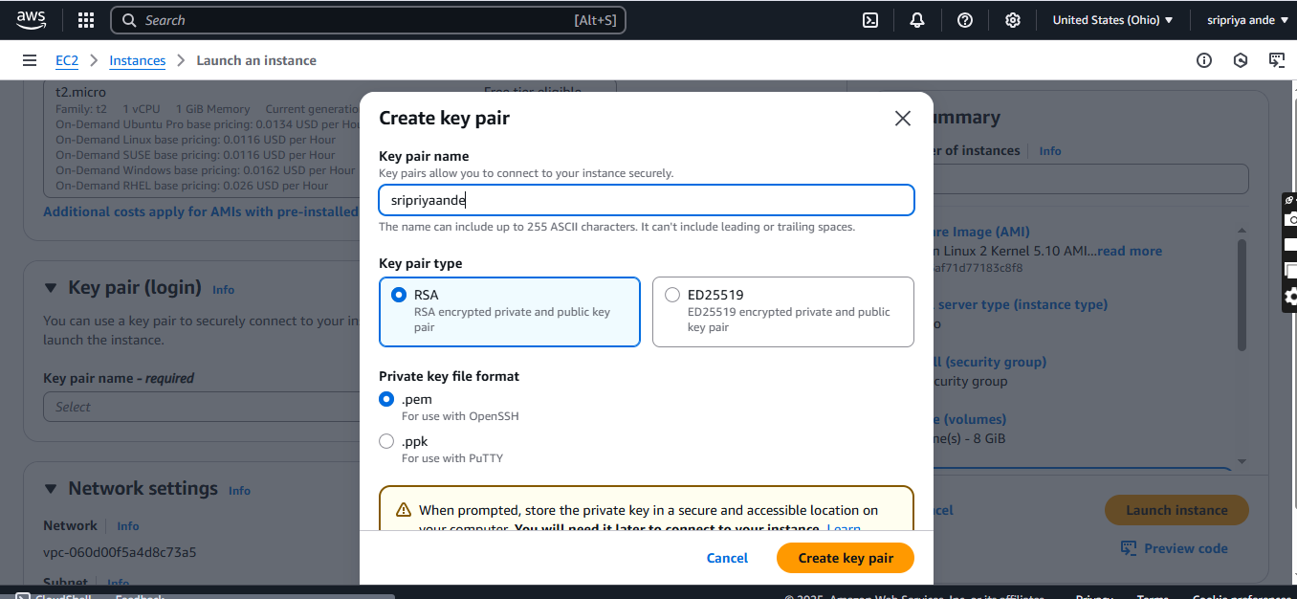

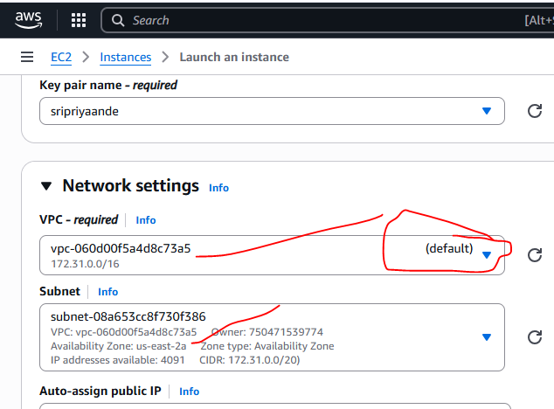

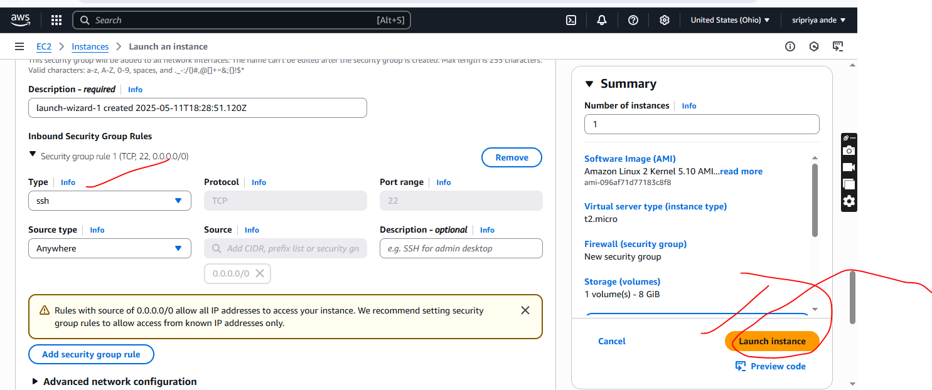

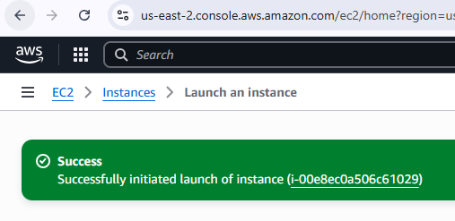

One region public IP and other region private IP

Internet is cnnected

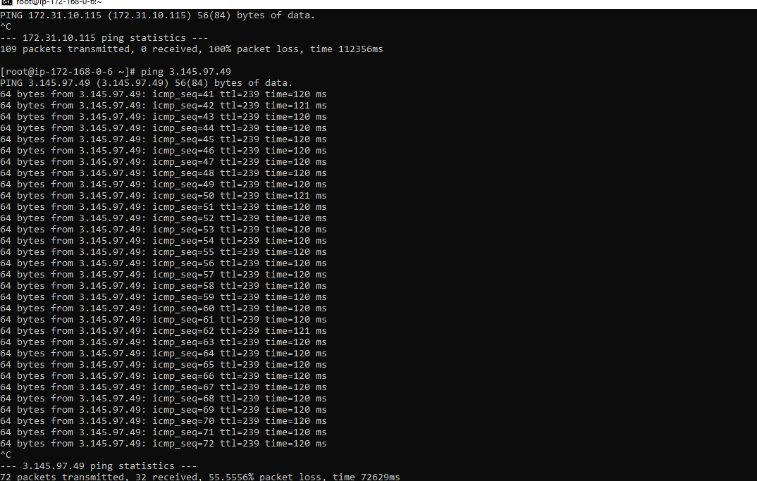

One region public IP and other region private IP

Internet is not cnnected

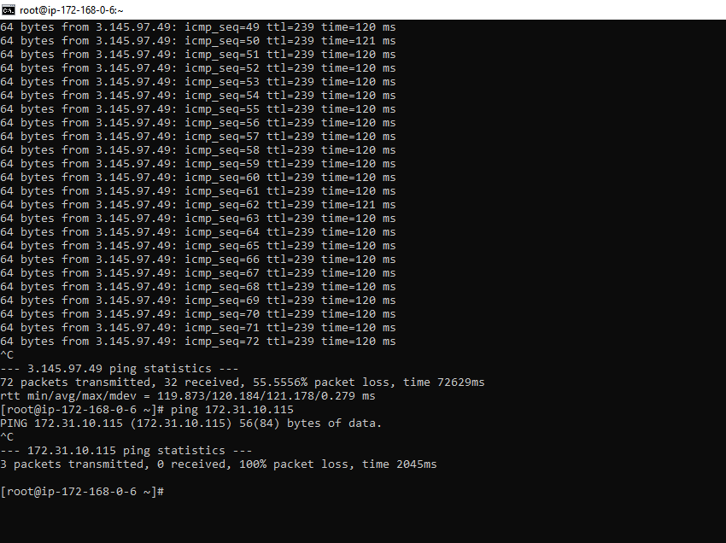

Same region public ip and same region private in another instance connected

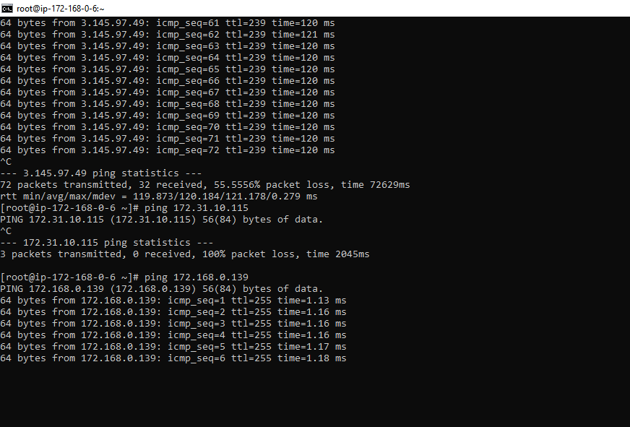

* To peering In one region (eg:europe)in open VPC
* In vpc --->peering connection-->create peering
* Name (eg:peering-europe-ohio)
* Select a local vpc to peer(Myvpc)
* Select another region to peer (my account and region is ohio)
* VPC id of another region or accepter
* Click on create it will pop one message as peering vpc europe to vpc ohio requested
* To peer now we have to accept the request now go to end user(ohio)
* Go to vpc ohio
* Click on peering connection
* You can see penidng acceptance
* Select and click on action
* You can find acceptrequest
* Click on that
* Then acceptance establishes the connection
* Now go to VPC(europe)---->route table --->publicRT-->edit route
* Add route(add cIDR range of ohio copy from ohio)
* Peering connection-->select peering id---->save chnages
* Similary go to another region vpc(ohio)
* VPC(ohio)---->route table --->publicRT-->edit route
* Add route(add cIDR range of europe copy from europe)
* Target Peering connection-->select peering id---->save chnages
* Now go to bash ,here connect with Europe public ec2
* Ping private<private ip>(ohio)
* Connected sucessfully
* 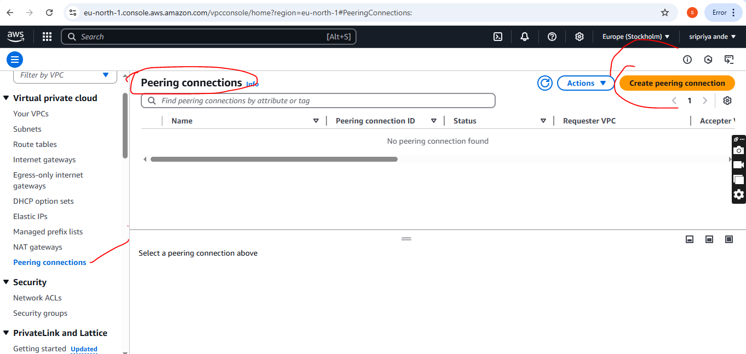

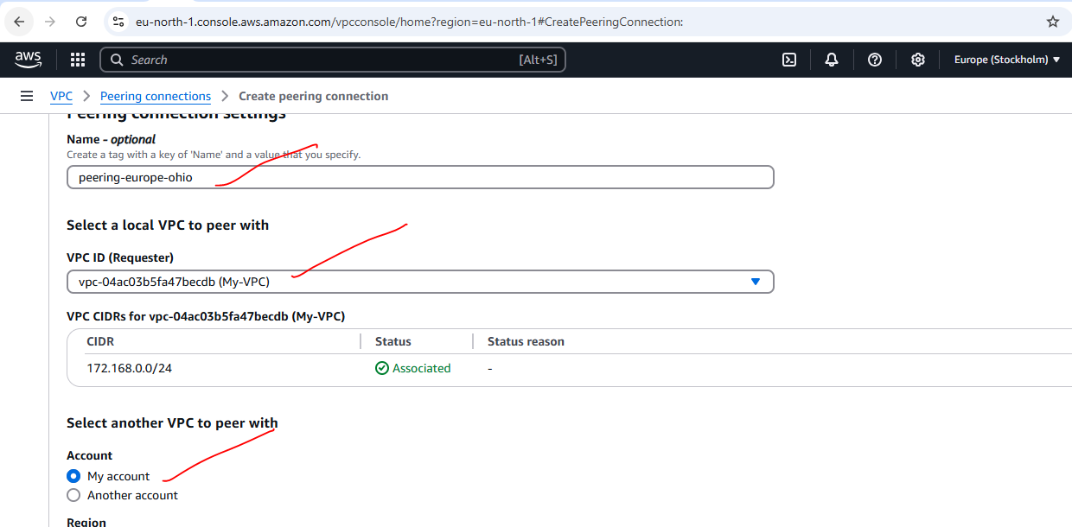

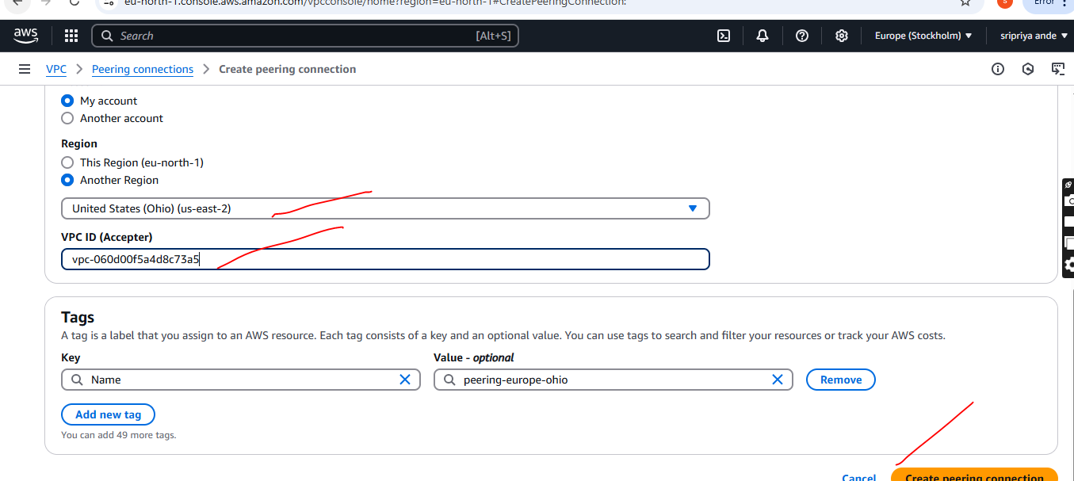

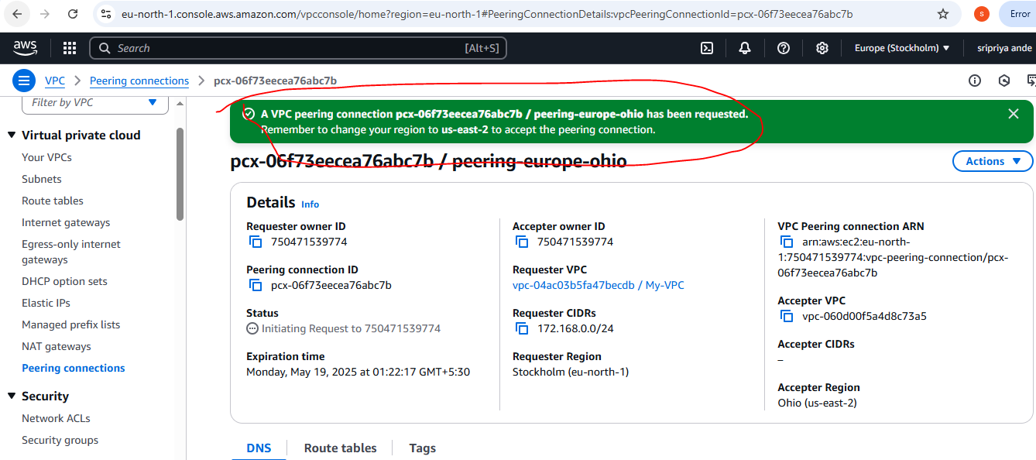

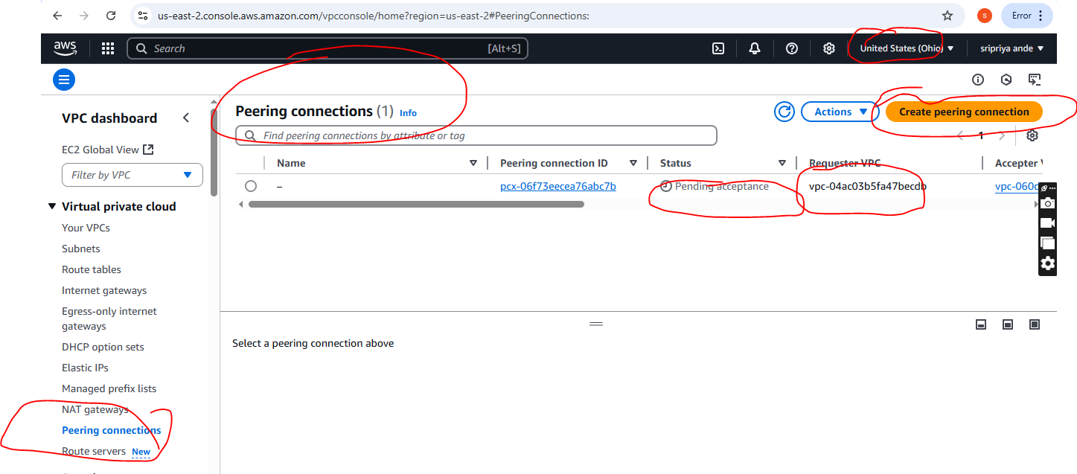

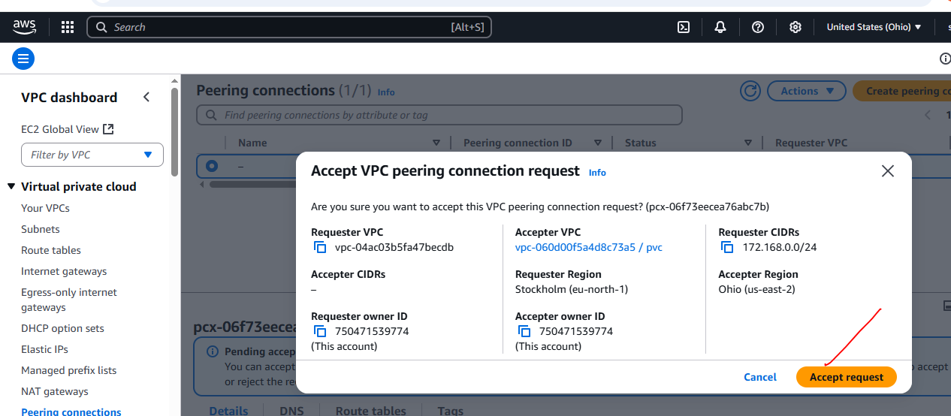

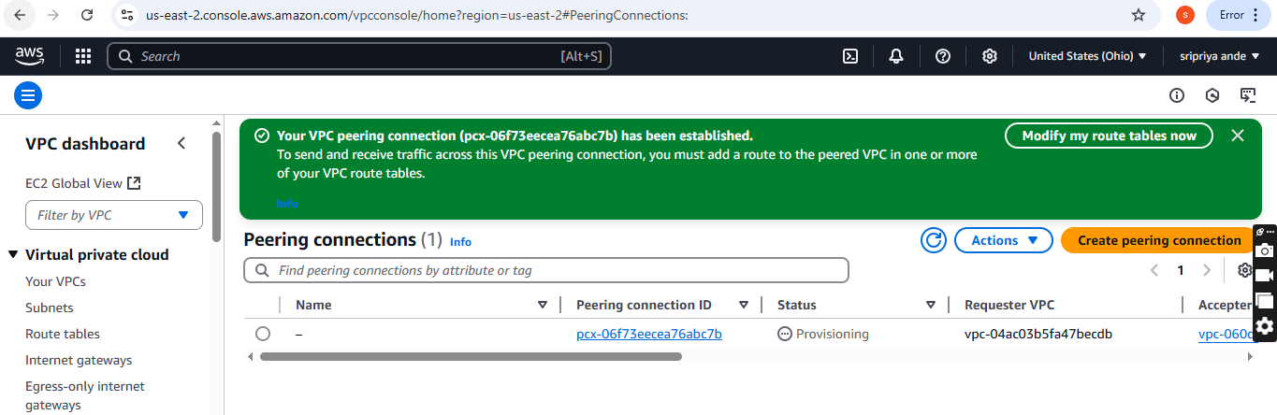

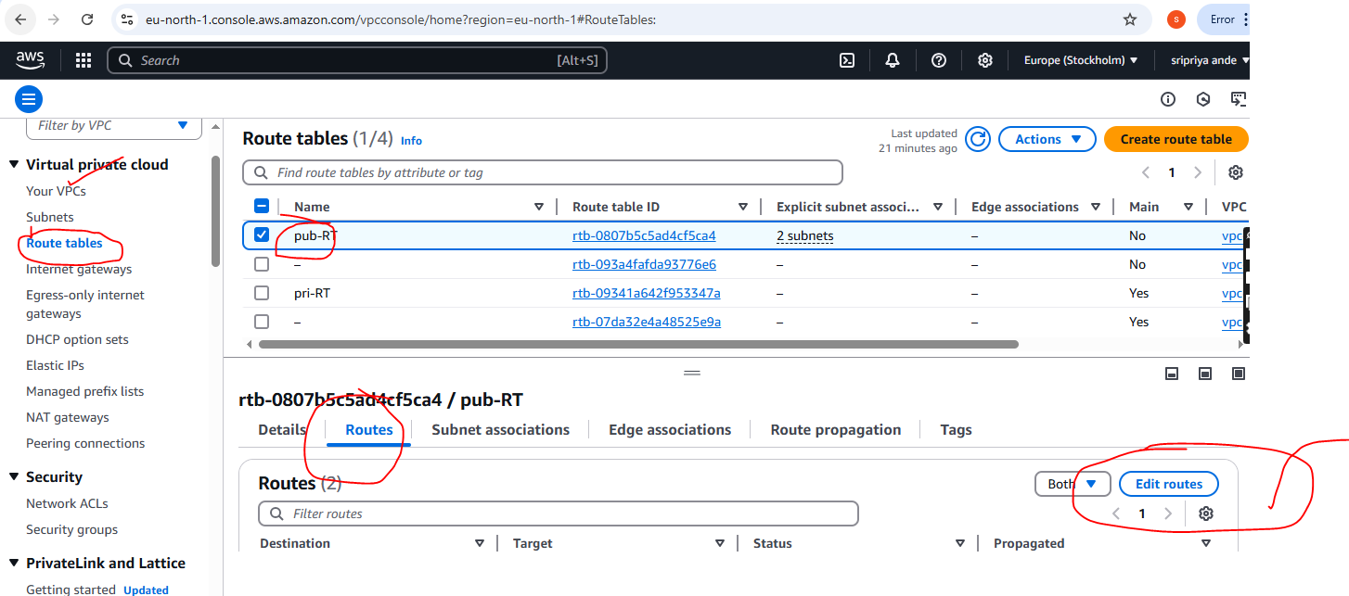

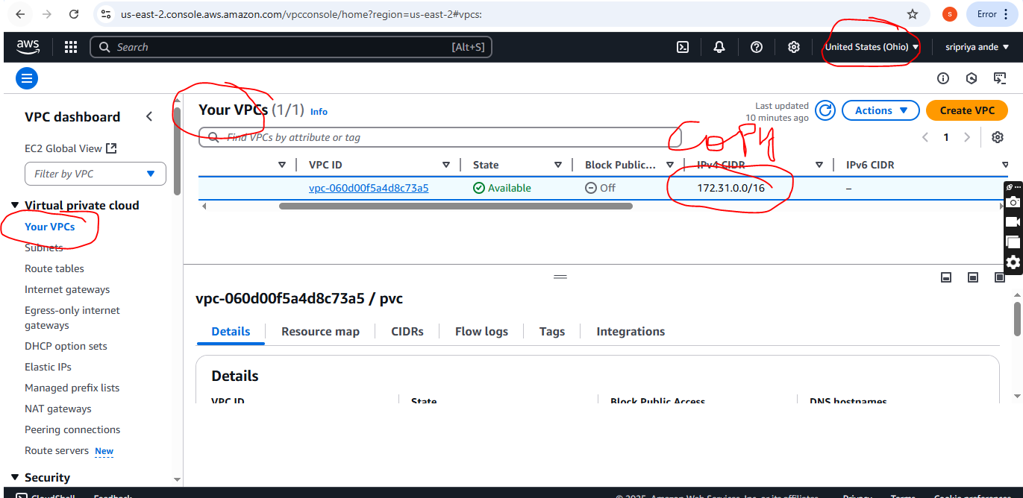

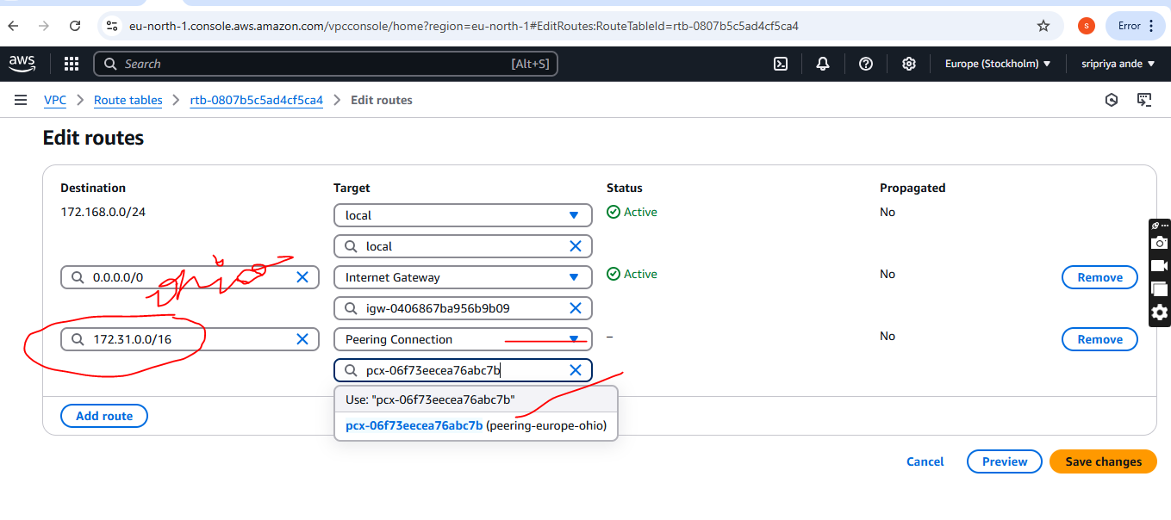

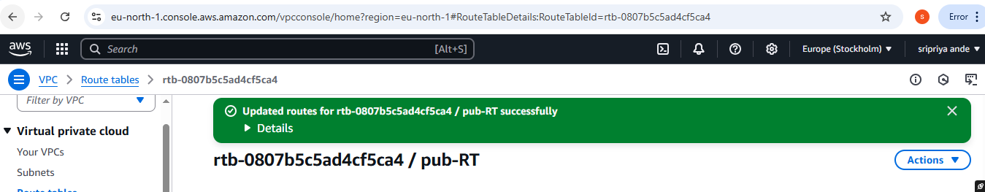

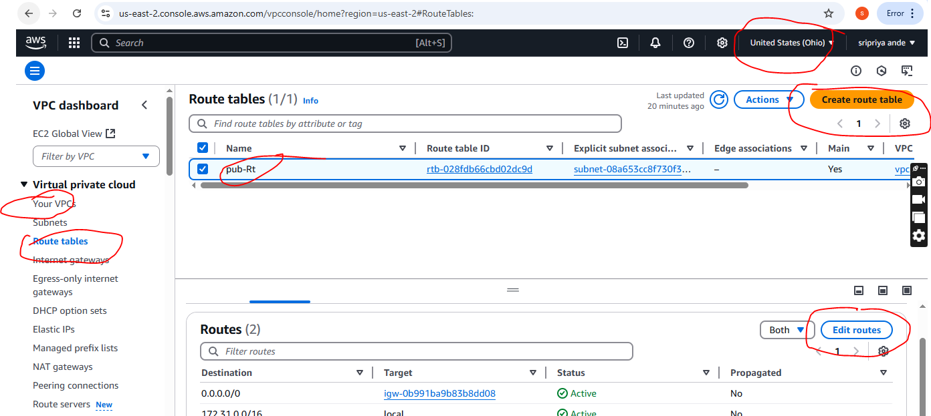

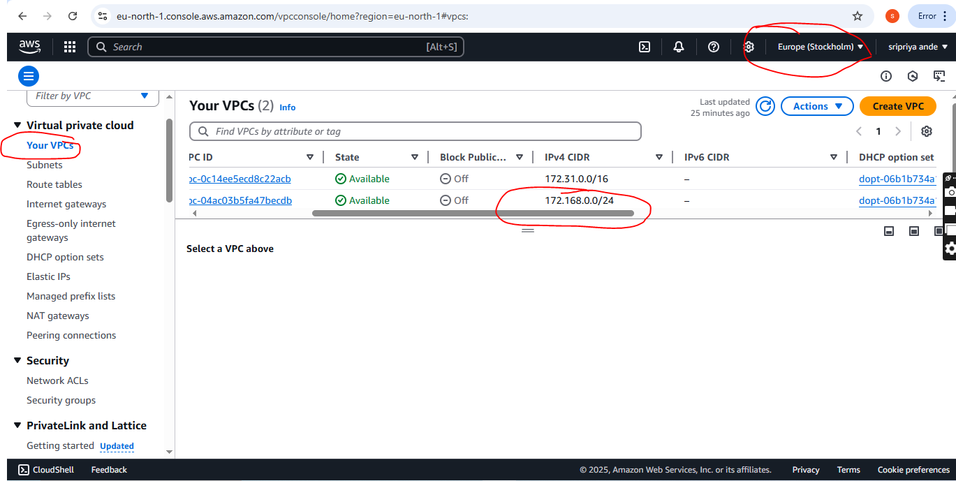

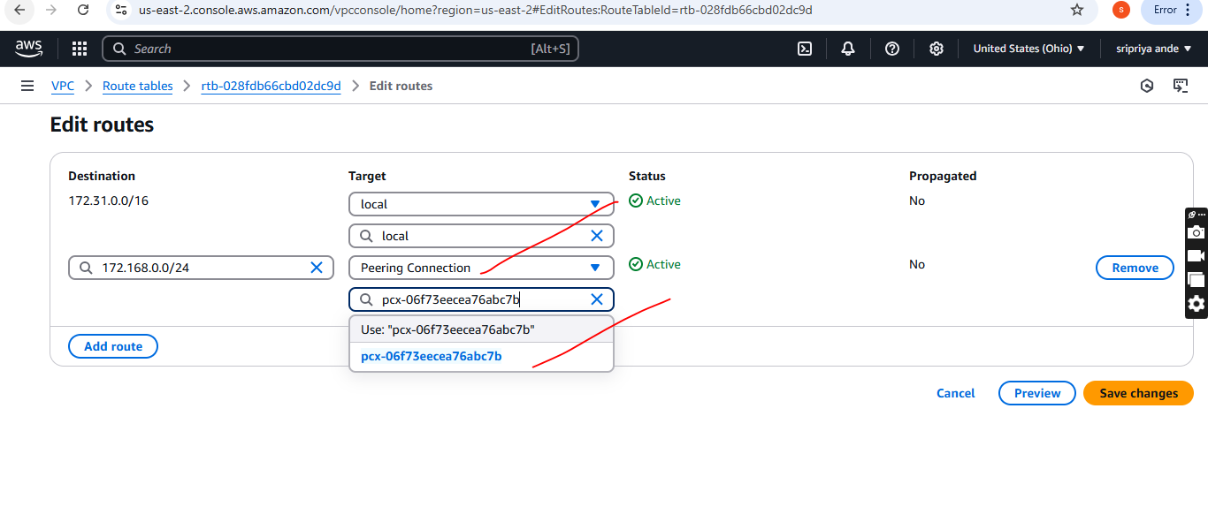

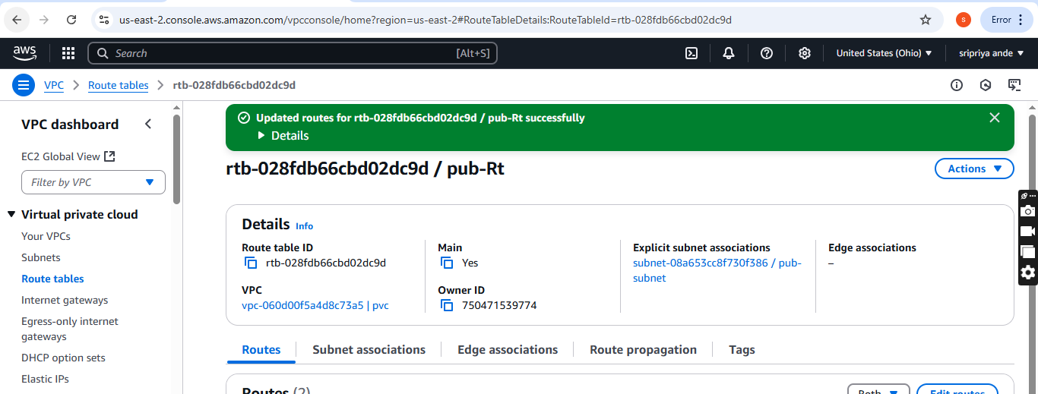

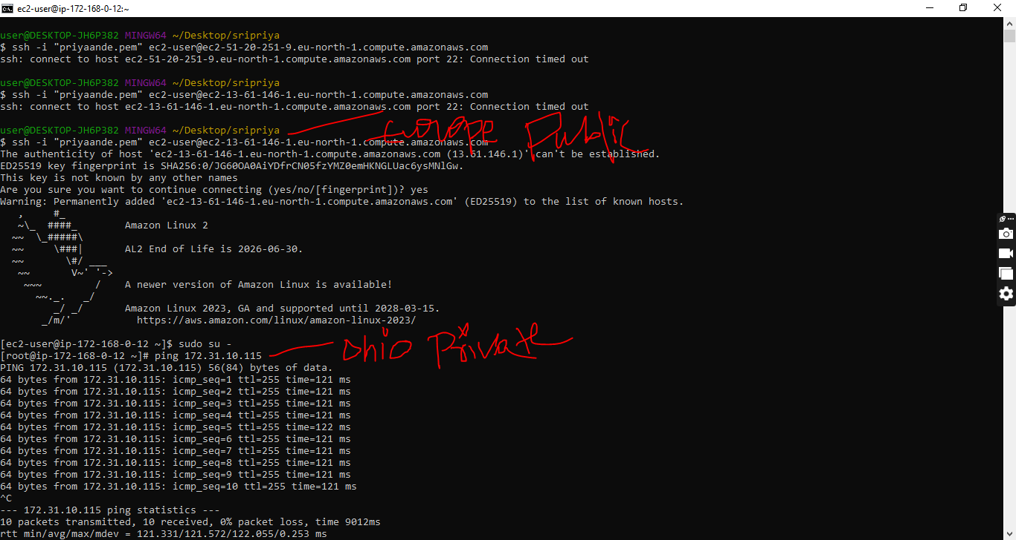

1. **Purchase one domain from godaddy.**

* Open a browser Go to godaddy website
* Click on sign in /sign up
* Search for domain(select domain for testing purpose)
* Continue and make it yours
* Remove full domain protection
* Disable create a free website
* Remove professional emails
* Continue and then pay
* After purchasing Go to account --->In products ---->We can find our domain

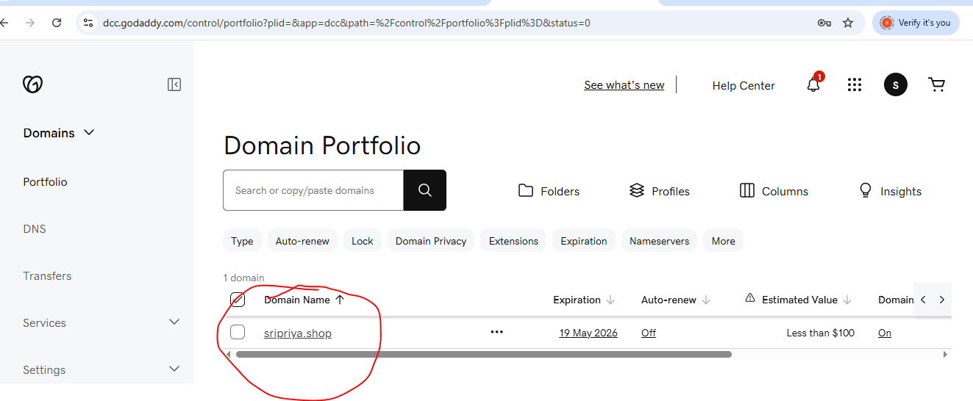

1. **Deploy static webiste in s3.**

* Go to s3 bucket
* In properties scroll down we can find **Static website hosting**
* Click on and Enable and upload index and error document
* And also upload these document from local to S3 bucket and make it public

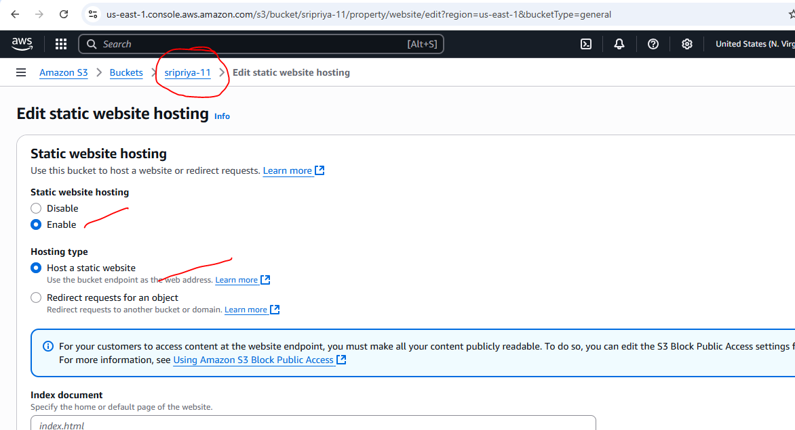

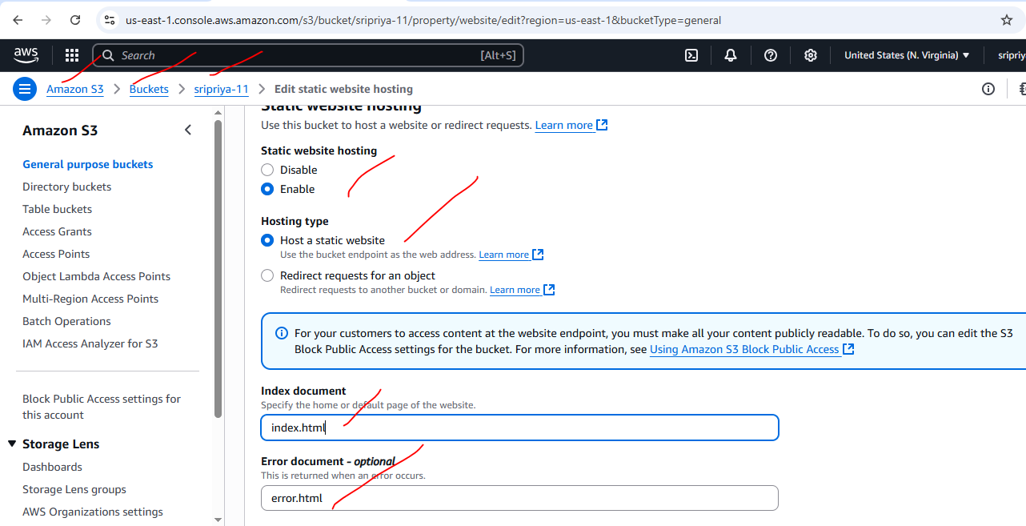

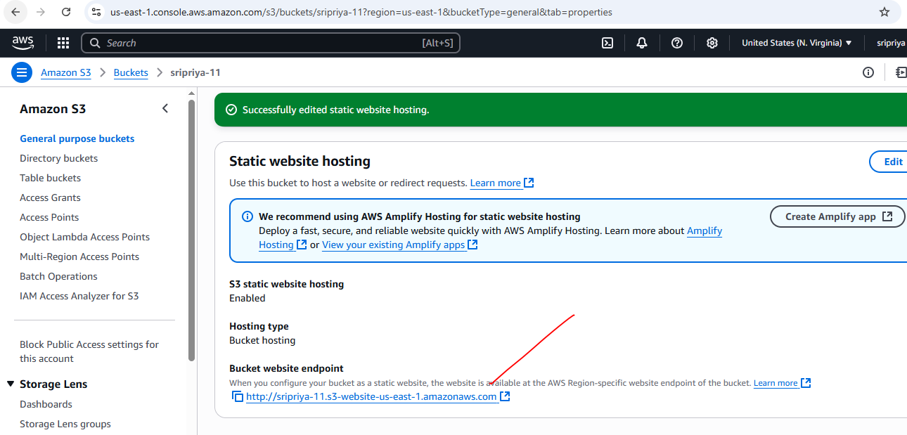

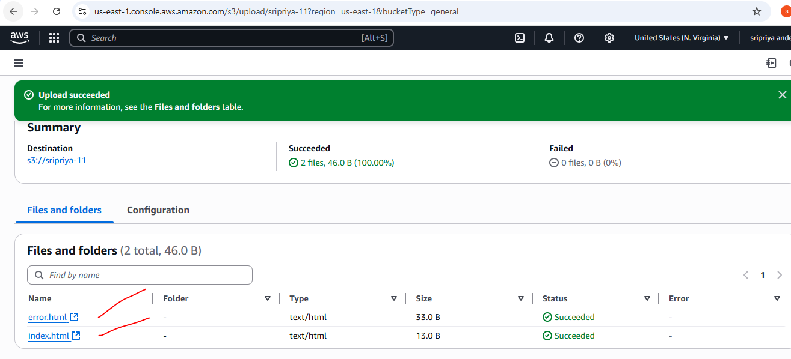

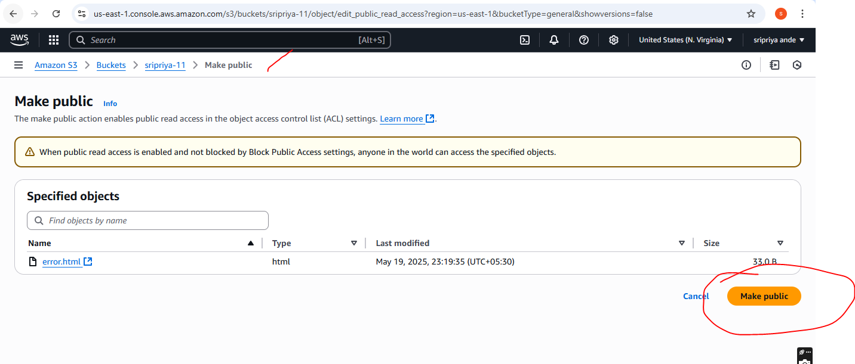

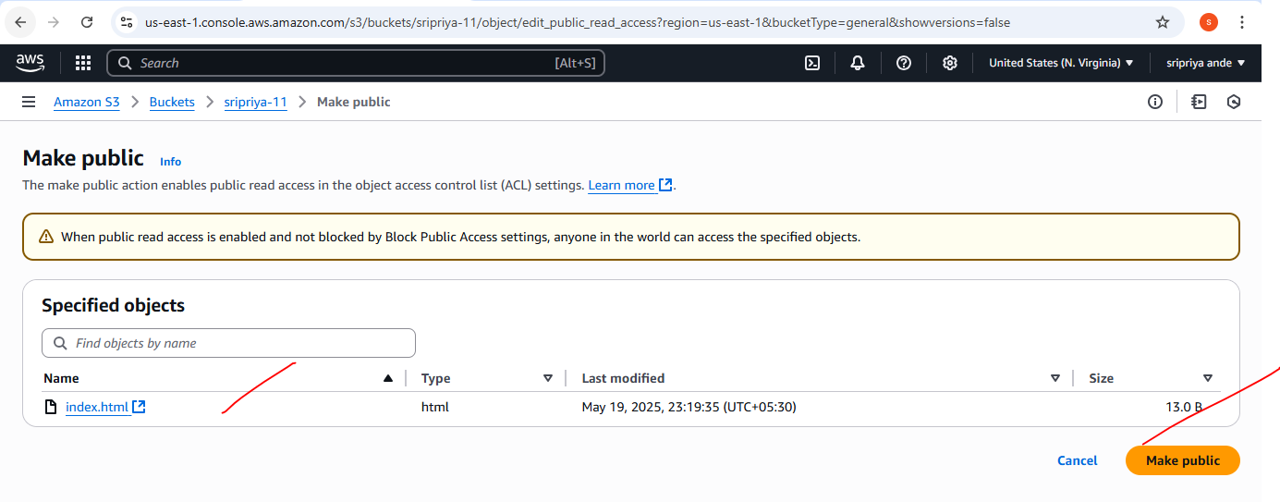

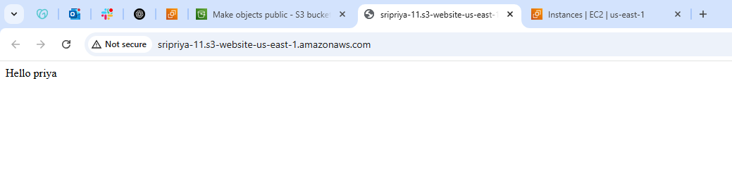

1. **Create CDN and attach one SSL certificate.**

* Go to Cloud front and create Distribution
* Choose original domain name
* Now we need to create ACM to Cloud front
* Seaching ACM in aws consle or got distribution and in settings click on edit
* In edit request cetificate
* And create on ACM certificate
* Now Go to Route53 ---->Go to hosted zones--->Records
* Create record

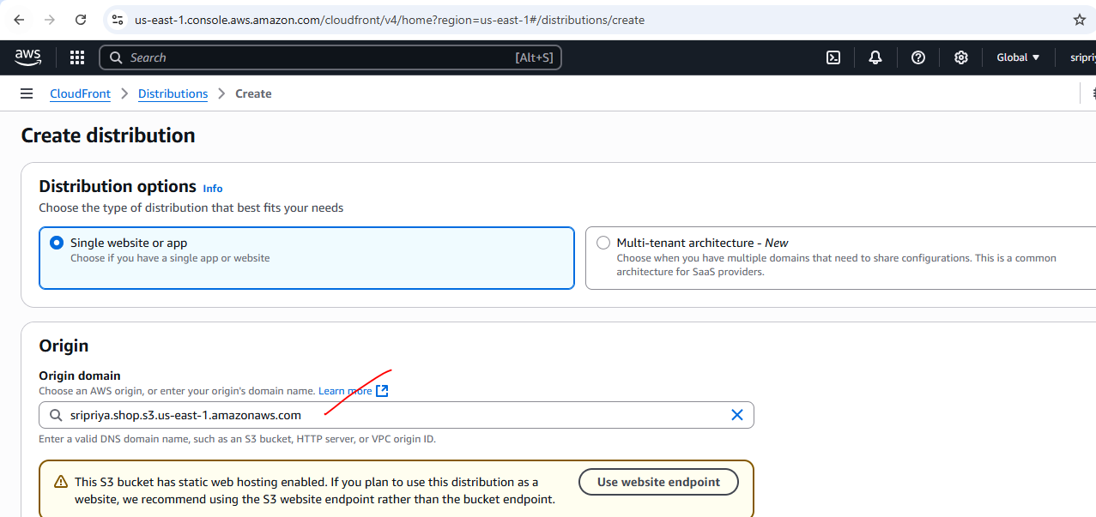

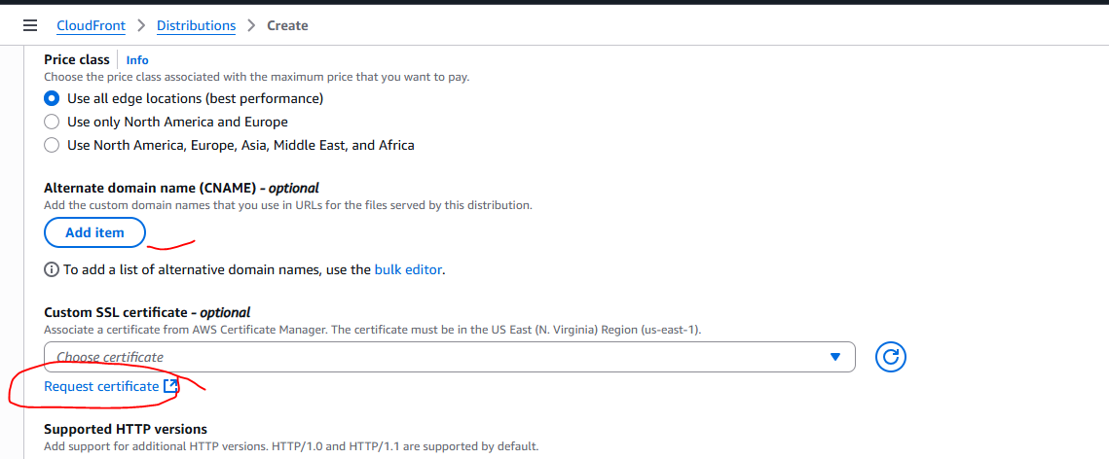

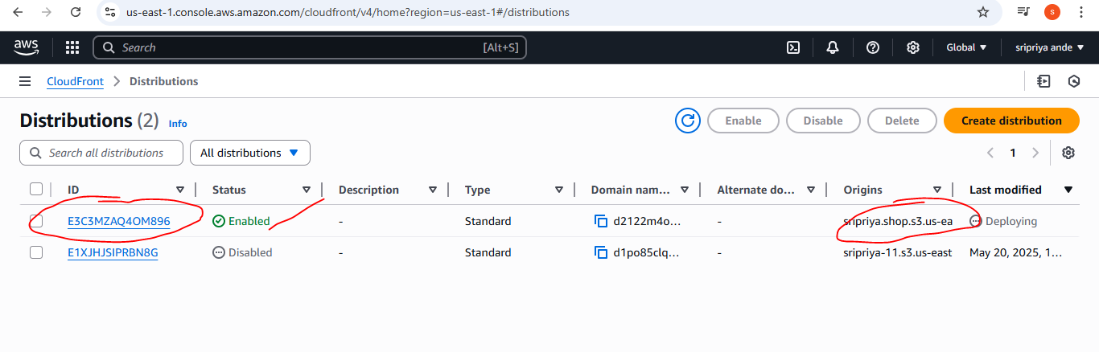

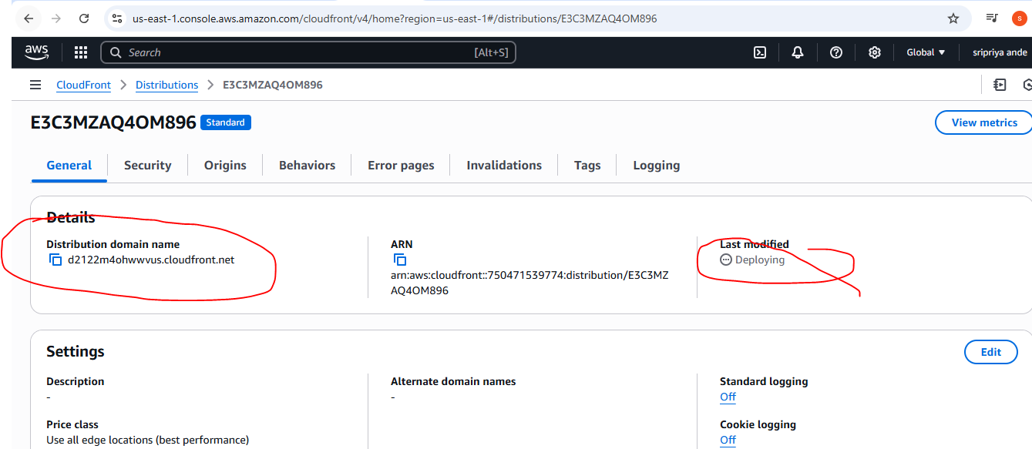

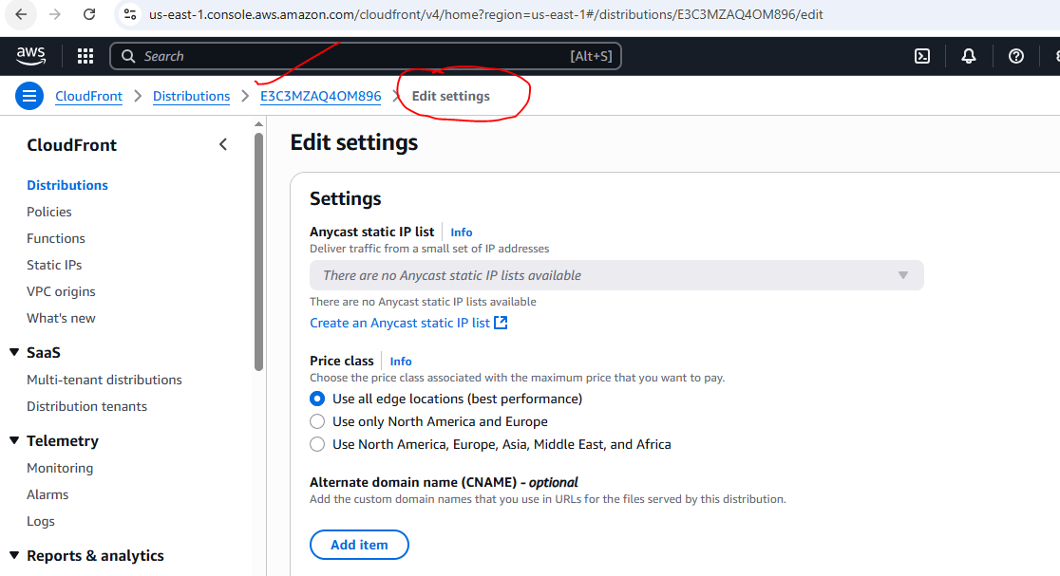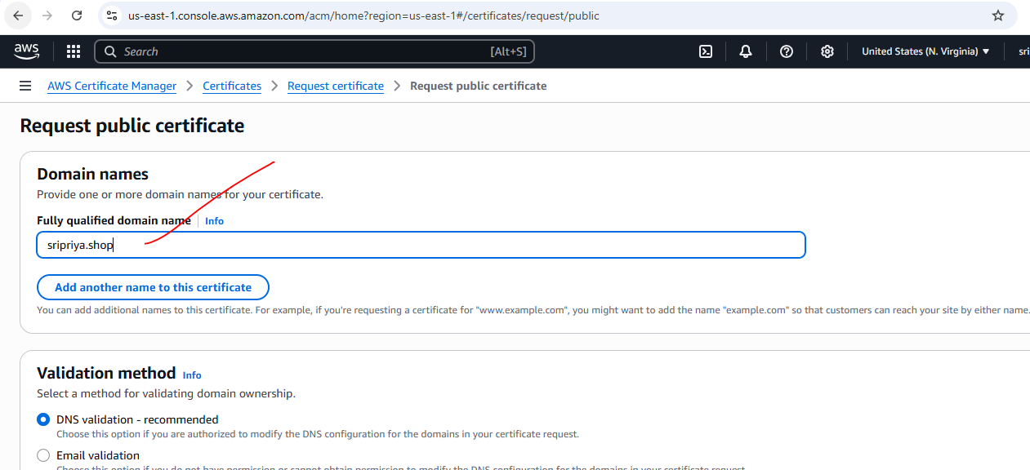

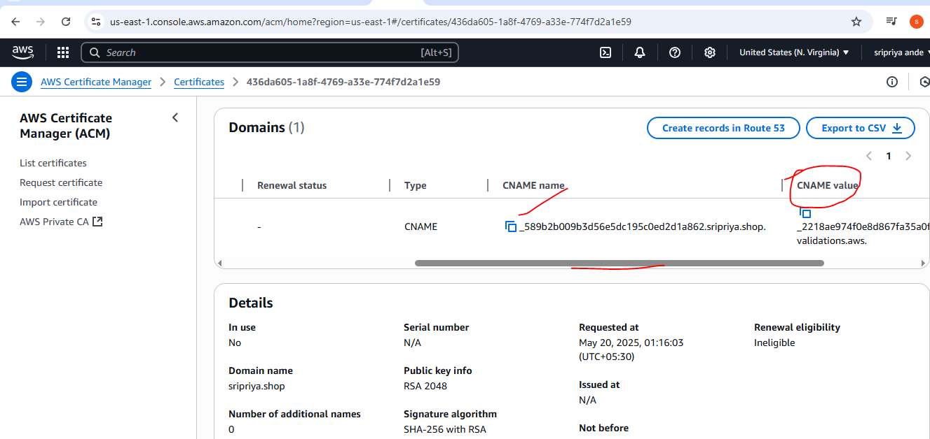

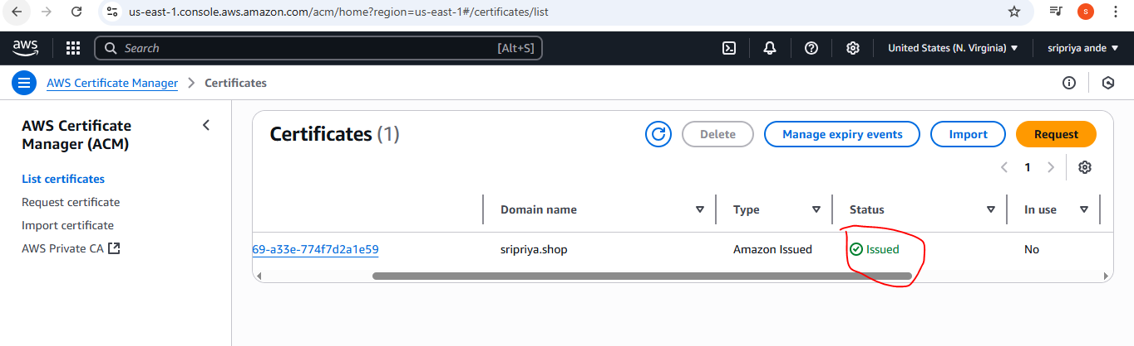

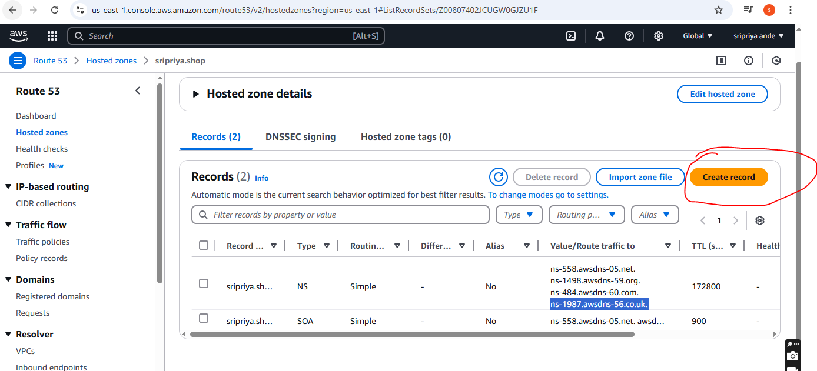

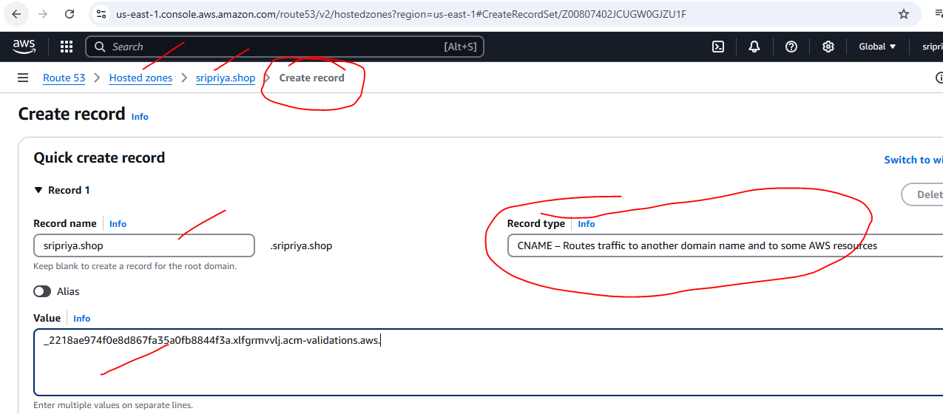

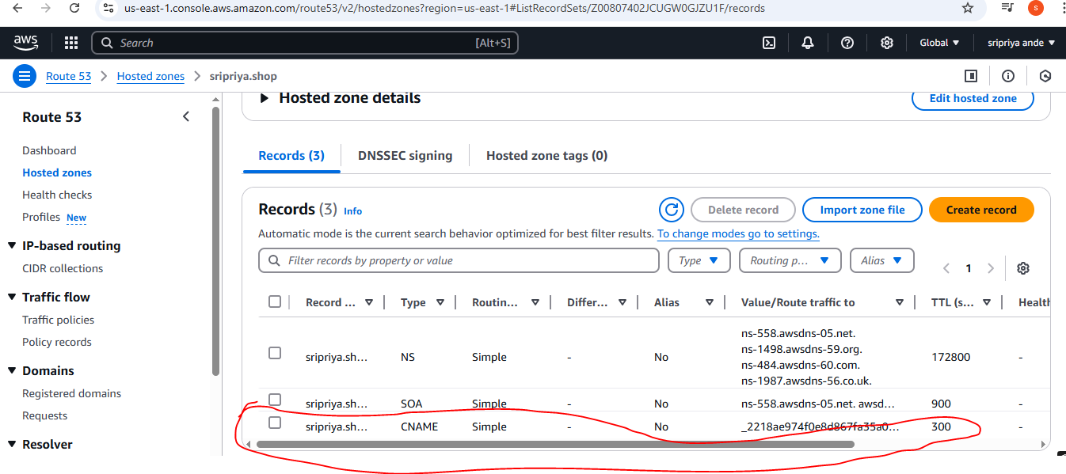

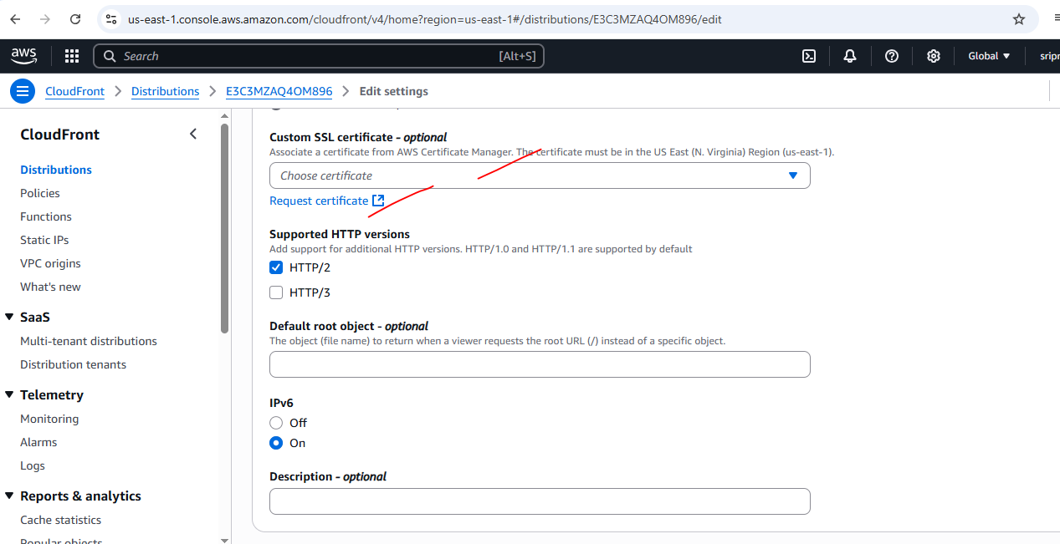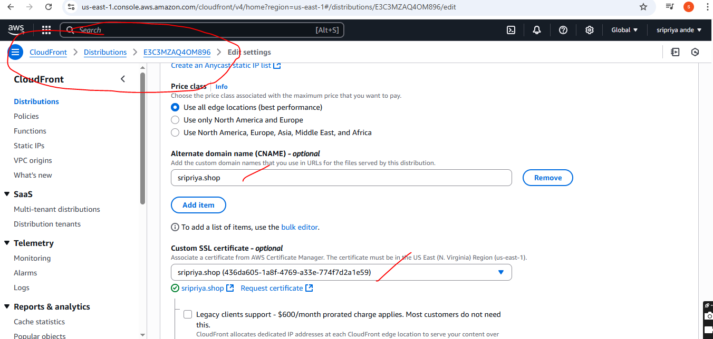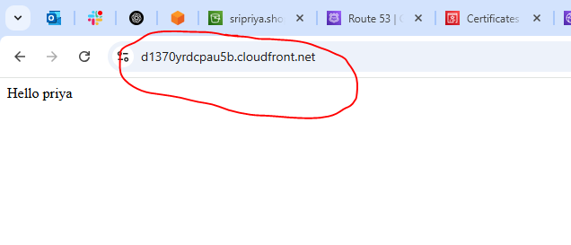

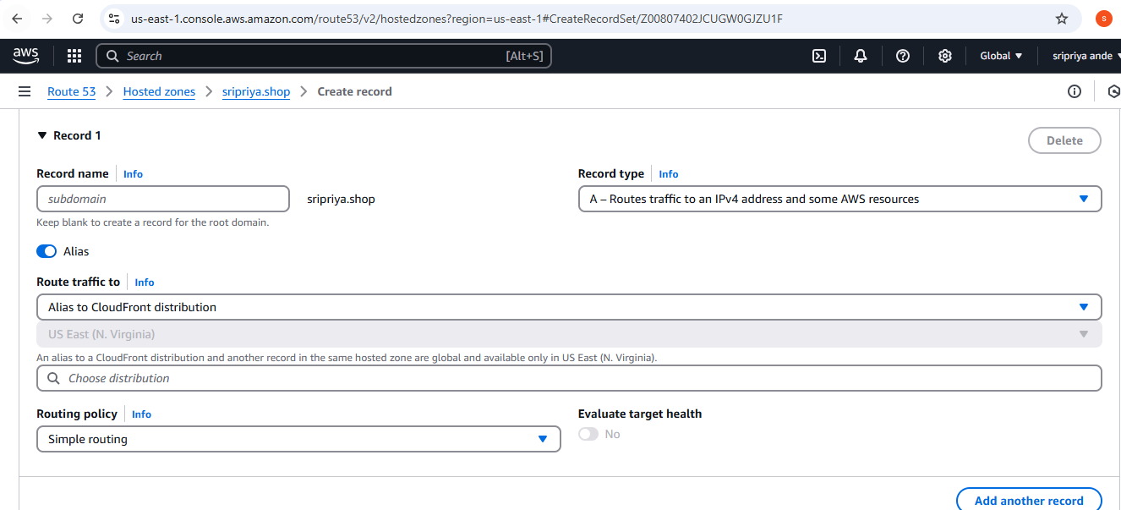

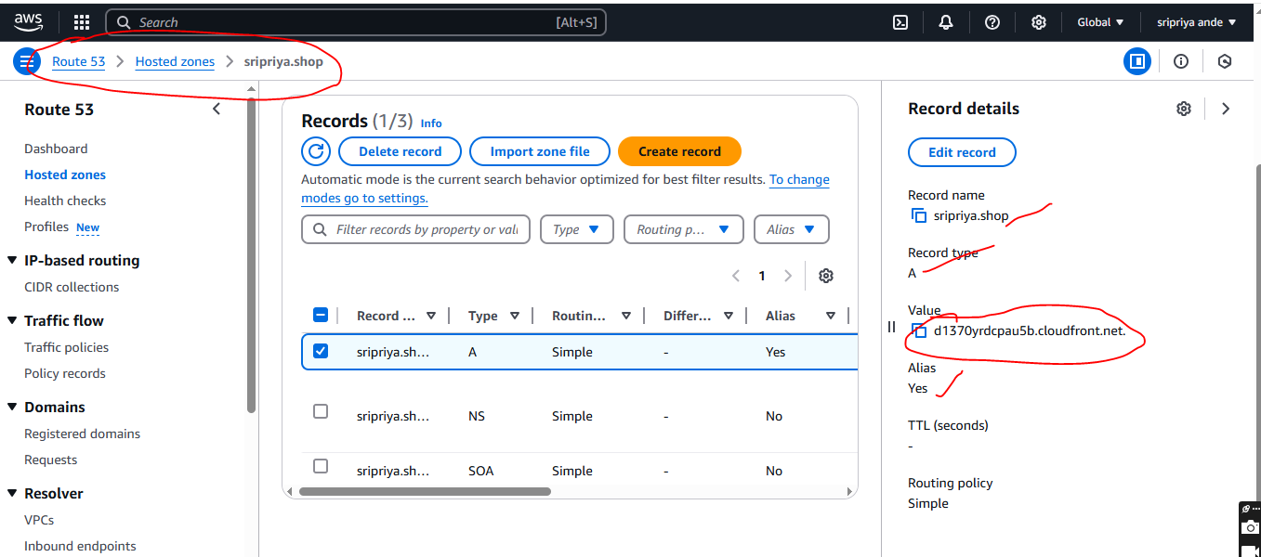

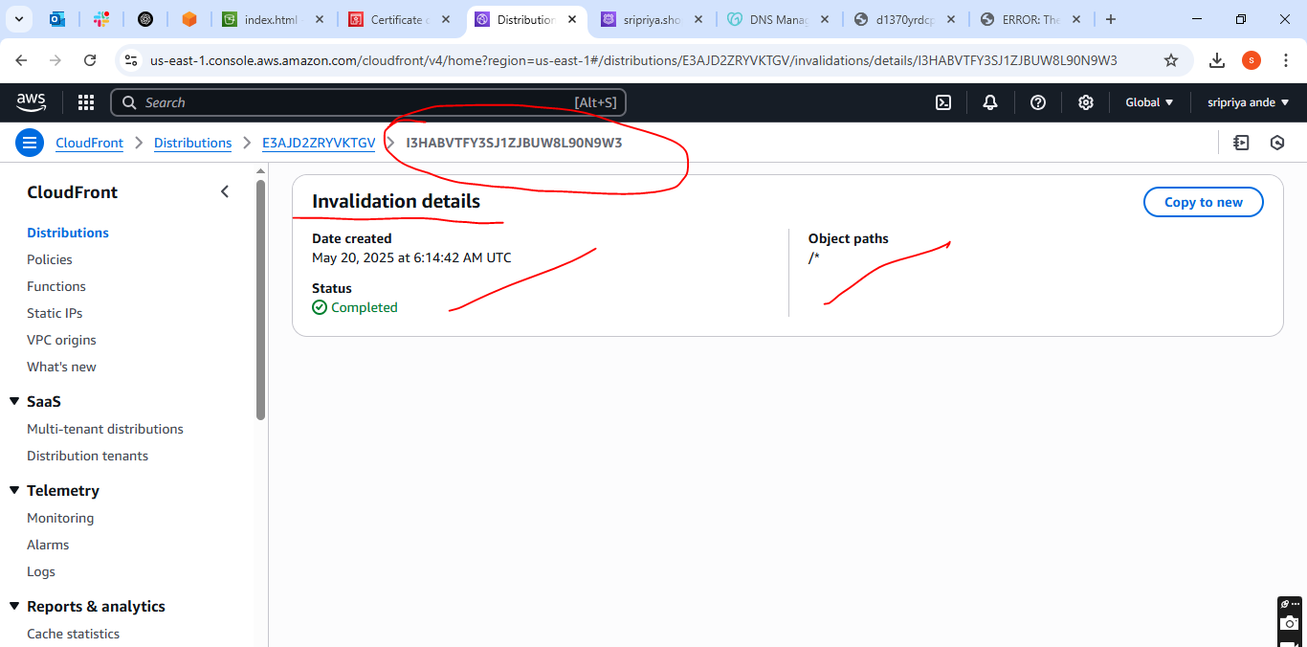

1. **Create Route53 hosted zone and MAP the domain with CDN.**

* Go to Route53 --->click on create hosted zones
* After created in records we find values
* Copy those values and Now Go to domain where we purchsed
* Domain --->DNS--->Namesevers--->paste these values in name server
* Save

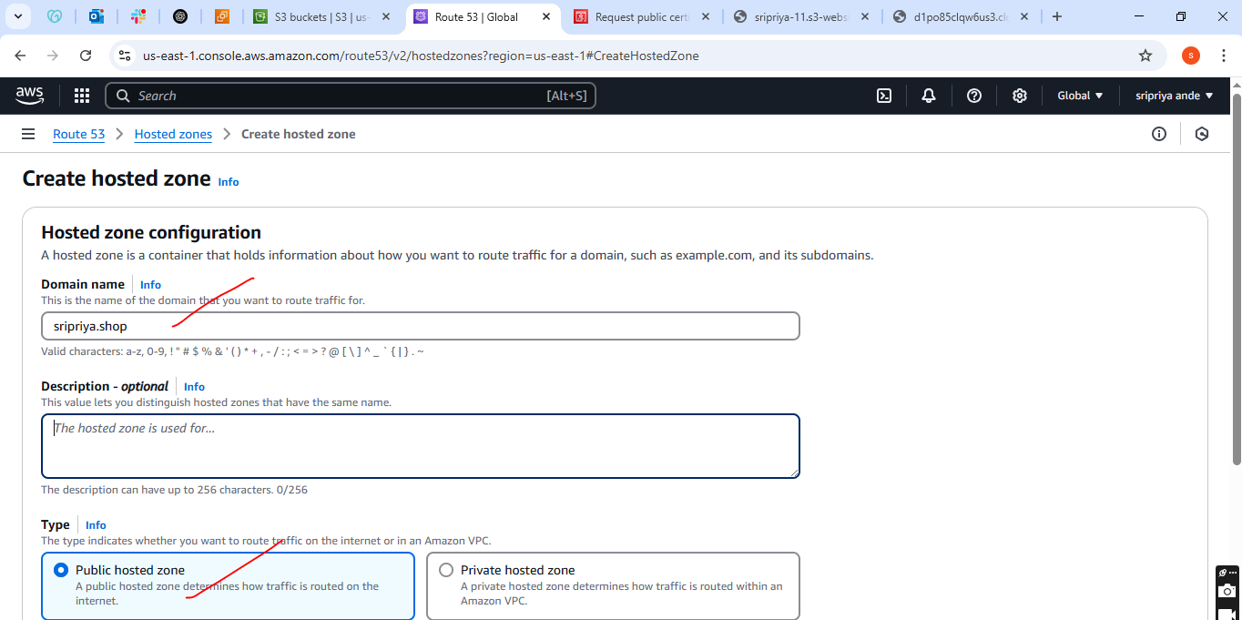

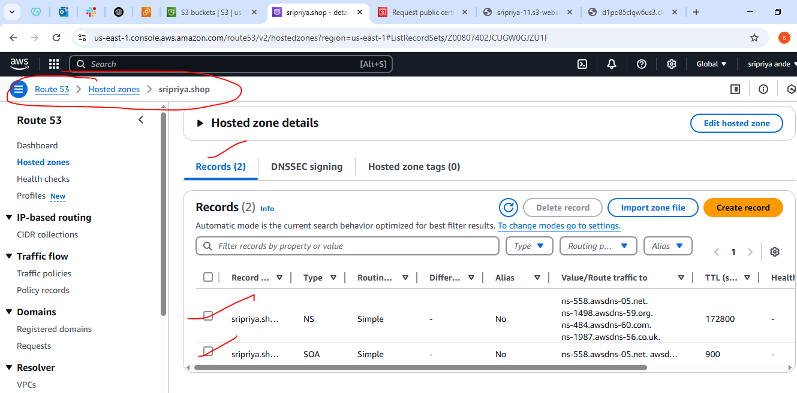

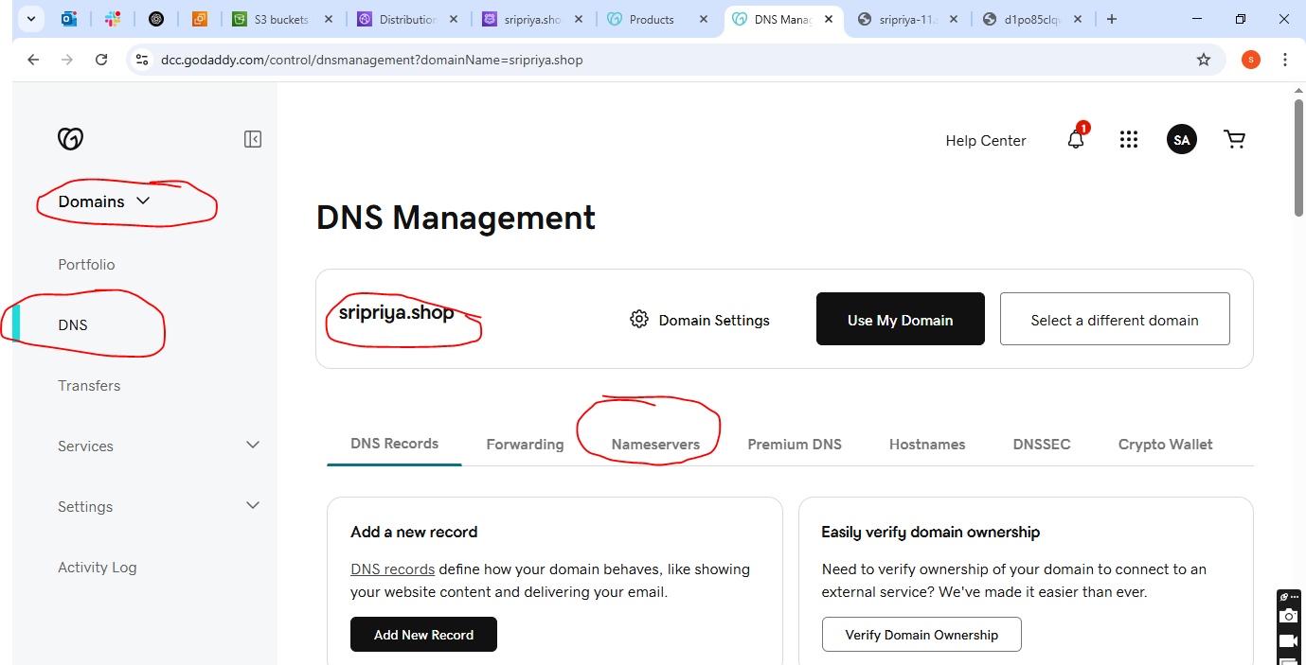

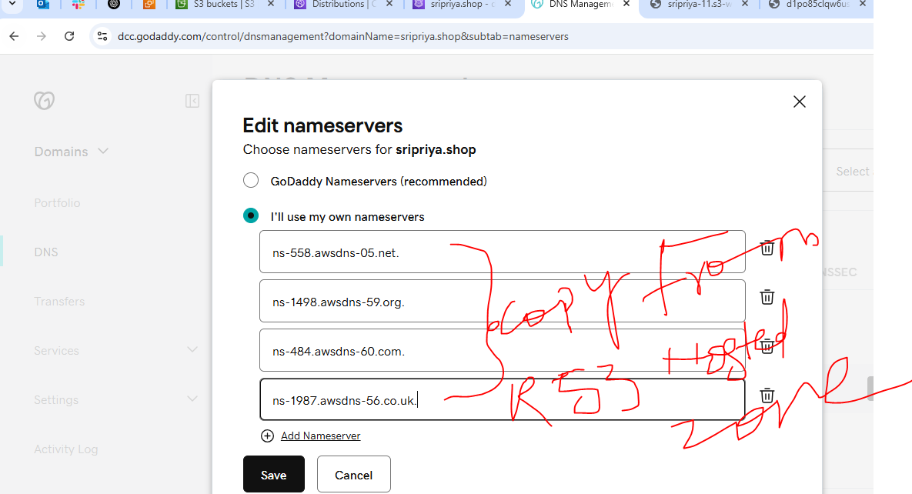

1. **Update the index.html in s3 bucket and the updated file should be accessible by using domain name.**

* After uploading documents
* Go to S3 bucket -->permissions-->bucket policy edit and write json to connect aws and cloudfront
* **save**

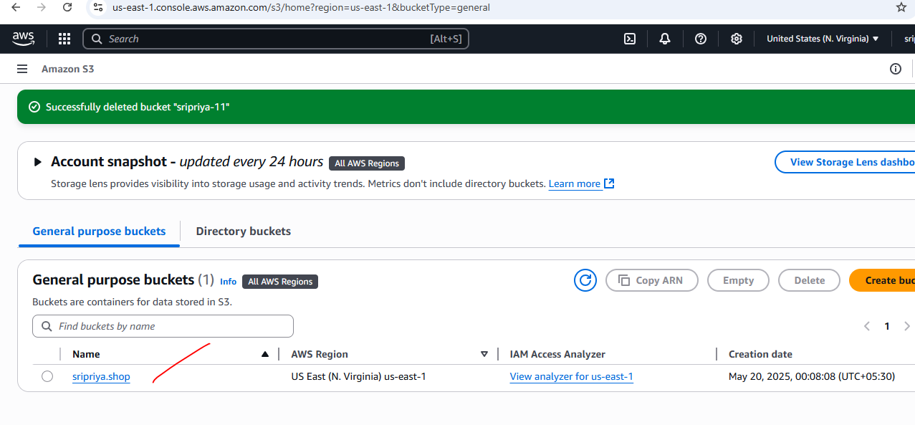

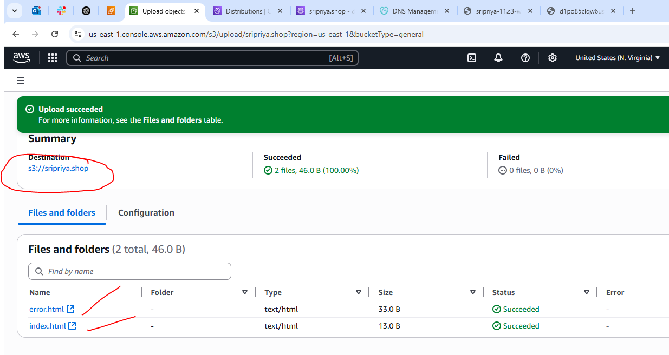

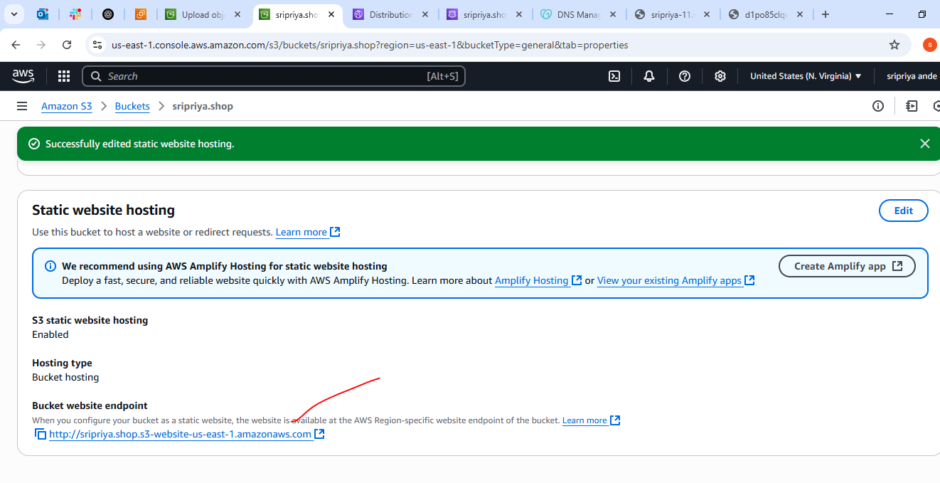

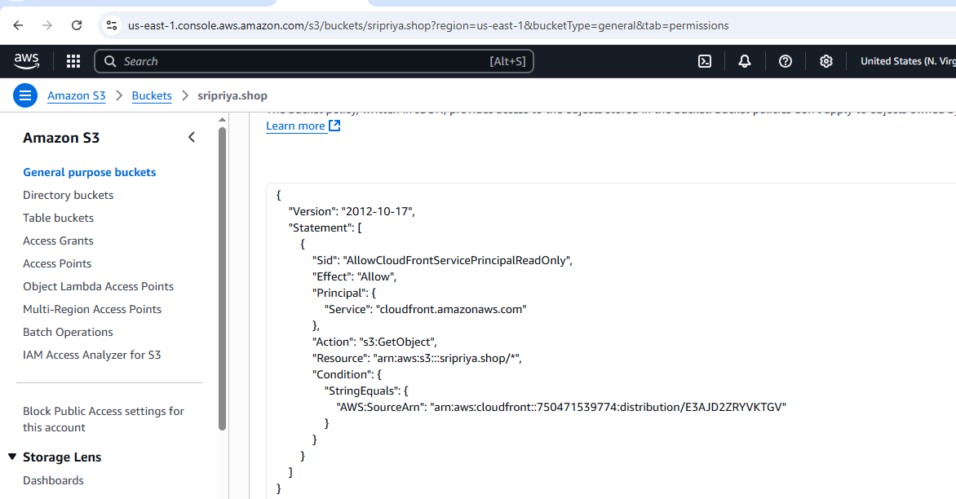

1. **Share the Domain name in slack to test the connetivity.**

**https://sripriya.shop/**

